Practical 1 : Create your resume using HTML tags. Experiment with colors, text, link,

and also other tags you studied.

<!DOCTYPE html>

<html>

<head>

<title>My Resume</title>

<meta charset="utf-8">

<meta name="viewport" content="width=device-width, initial-scale=1">

<link rel="stylesheet" href="https://maxcdn.bootstrapcdn.com/bootstrap/4.4.1/css/bootstrap.min.css">

<script src="https://ajax.googleapis.com/ajax/libs/jquery/3.4.1/jquery.min.js"></script>

<script src="https://cdnjs.cloudflare.com/ajax/libs/popper.js/1.16.0/umd/popper.min.js"></script>

<script src="https://maxcdn.bootstrapcdn.com/bootstrap/4.4.1/js/bootstrap.min.js"></script>

<style>

table, th, td {

border: 1px solid black;

border-collapse: collapse;

}

</style>

</head>

<body style="background-color: gray;">

<div class="container" style="background-color: white;">

<center><h2>Resume</h2></center>

<hr>

<div class="row">

<div class="col-sm-8">

<p><b><i>Name:</i></b> &nbsp;Harshil Patel</br>

<b><i>Address:</i></b> &nbsp;Ghatlodia,Ahmedabad</br>

<b><i>Mobile No:</i></b> &nbsp;9512103667</br>

<b><i>EmailID:</i></b> &nbsp;hackwithharshil@gmail.com</br>

<b><i>Github:</i></b> &nbsp;<a href="https://github.com/hackershil" target="_blank" style="text-decoration: none;">hackershil</a></br>

</p>

</div>

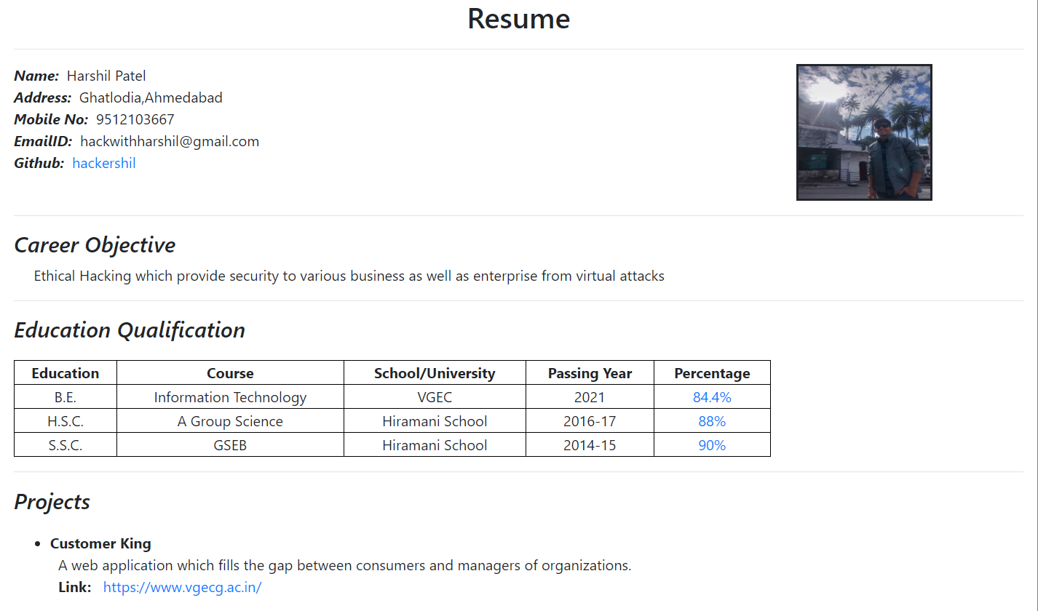 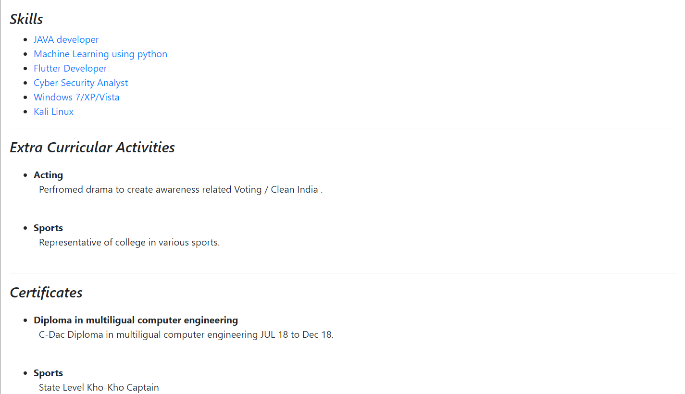

<div class="col-sm-4">

<center><img src="1.jpg" width="150" height="150" style="border: solid;"></center></div></div><hr>

<div class="row">

<div class="col-sm">

<h4><i>Career Objective</i></h4>

<p>&nbsp;&nbsp;&nbsp;&nbsp;&nbsp;Ethical Hacking which provide security to various business as well as enterprise from virtual attacks</p>

<hr>

<h4><i>Education Qualification</i></h4>

<table style="width:75%;text-align: center;margin-top: 20px;">

<tr>

<th>Education</th>

<th>Course</th>

<th>School/University</th>

<th>Passing Year</th>

<th>Percentage</th>

</tr>

<tr>

<td>B.E.</td>

<td>Information Technology</td>

<td>VGEC</td>

<td>2021</td>

<td><a href="#">84.4%</a></td>

</tr>

<tr>

<td>H.S.C.</td>

<td>A Group Science</td>

<td>Hiramani School</td>

<td>2016-17</td>

<td><a href="#">88%</a></td>

</tr>

<tr>

<td>S.S.C.</td>

<td>GSEB</td>

<td>Hiramani School</td>

<td>2014-15</td>

<td><a href="#">90%</a></td>

</tr>

</table>

<hr>

<h4><i>Projects</i></h4>

<ul style="margin-top: 20px;">

<li>

<b>Customer King</b>

<p>&nbsp;&nbsp;A web application which fills the gap between consumers and managers of organizations.</br>&nbsp;&nbsp;<b>Link:</b><a href="http://cutomerkings.000webhost.com/" target="_blank"> &nbsp;&nbsp;https://www.vgecg.ac.in/</a></p>

</li></ul>

<hr>

<h4><i>Skills</i></h4>

<ul>

<li><a href="http://java.sun.com">JAVA developer</a></li>

<li><a href="https://expertsystem.com/machine-learning-definition/">Machine Learning using python</a></li>

<li><ahref="https://flutter.dev/?gclid=EAIaIQobChMItpTylrPL5gIVRRSPCh2tQQxtEAAYASAAEgJoPvD_BwE">Flutter Developer</a></li>

<li><a href="https://digitalguardian.com/blog/what-cyber-security">Cyber Security Analyst</a></li>

<li><a href="https://www.microsoft.com/en-in/windows/windows-7-end-of-life-support-information">Windows 7/XP/Vista </a></li>

<li><a href="https://www.kali.org/">Kali Linux</a></li>

</ul>

<hr>

<h4><i>Extra Curricular Activities </i></h4>

<ul style="margin-top: 20px;">

<li>

<b>Acting</b>

<p>&nbsp;&nbsp;Perfromed drama to create awareness related Voting / Clean India .</br>

&nbsp;&nbsp;</p>

</li>

<li>

<b>Sports</b>

<p>&nbsp;&nbsp;Representative of college in various sports.</br>

&nbsp;&nbsp;</p>

</li></ul>

<hr>

<h4><i>Certificates </i></h4>

<ul style="margin-top: 20px;">

<li>

<b>Diploma in multiligual computer engineering</b>

<p>&nbsp;&nbsp;C-Dac Diploma in multiligual computer engineering JUL 18 to Dec 18.</br>

&nbsp;&nbsp;</p>

</li>

<li>

<b>Sports</b>

<p>&nbsp;&nbsp;State Level Kho-Kho Captain</br>

&nbsp;&nbsp;</p>

</li> </ul> </div> </div></div>

</body>

</html>